Exercises
- Follow all steps in this document. In the customer table, enter a fifth record:
CustomerID = 5 and CustomerName = your name (ie. If your name is Rita type Rita)
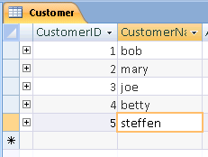

Take a screenshot of the customer table with your name as the CustomerName in the fifth field.

- Try and delete the row containing CustomerID=3 from the Customer table.
(a)Take a screenshot of the message and paste it into this document.

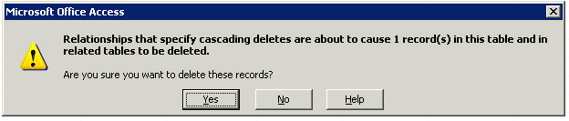

(b)Explain why the message appeared.

Referential integrity is being enforced and we have cascade deletes enabled. This means that when you delete a customer, who’s ID is associated with orders, the orders will be deleted as well.

(c)Explain how to modify your database so the message will not appear when deleting the row containing CustomerID=3 from the Customer table

Disable “Cascade Delete Related Records” in the relationships for the tables.

- In the Customer table, change joe’s customer number to 88.
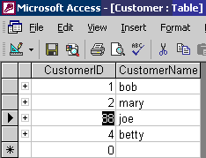
Notice that the CustomerID for joe’s order in the Order table is updated as well.
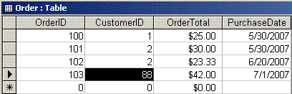
- Why does it get updated in the Order table?

The order table’s records get updated because we have “Cascade Update Related Fields” enabled, which automatically updates any related fields in order to maintain referential integrity.

- List one change to the database that you could make to prevent the CustomerID from being changed in the Order table when modifying the CustomerID in the Customer table.

To prevent the CustomerID from being changed in the Order table, you simply disable “Cascade Updated Related Fields” in the table relationships.

